**Customer Notice**

**Unknown** **Water Service Line Material**

**Water System Name: Hillsborough Water - Water System ID: 1141010**

Public Water System Name:

PWS ID:

# Why are you receiving this letter?

Because of new federal requirements for lead in drinking water, water systems must notify you that we do not have a record of the piping materials of your water service line. You and other water system customers are receiving this or a similar letter. The good news is that you can help your water system assess, and where necessary, make improvements to your water service lines. Please contact us via the phone or email below for assistance to report your service line materials. Until then, please follow the simple steps below recommended for everyone to prevent potential exposure to lead in drinking water.

# What are the Health Effects of Lead?

The Environmental Protection Agency requires we inform you the following: *Exposure to lead in drinking water can cause serious health effects in all age groups. Infants and children can have decreases in IQ and attention span. Lead exposure can lead to new learning and behavior problems or worsen existing learning and behavior problems. The children of women who are exposed to lead before or during pregnancy can have increased risk of these negative health effects. Adults can have increased risks of heart disease, high blood pressure, and kidney, or nervous system problems*.

# What Can I Do to Reduce Exposure to Lead in Drinking Water?

In addition to your service line (see figure on back), other plumbing in your home may contain lead and could increase the levels of lead in your drinking water. These may include faucets, valves, and soldered joints. Please contact us via the phone / email below to request a free water test and to confirm your service line materials. If you’re concerned about lead, the following measures can help you prevent potential lead exposure from any drinking water plumbing:

* **Identify your service line materials.** Contact your water systememail / phone listed below for assistance to identify your service line materials.
* **Run your water to flush out lead**. If the water hasn’t been used for several hours (such as in the morning) run the water for 1 minute or more to flush potential lead from interior plumbing before using it for drinking or cooking.
* Use **cold** water for cooking and preparing baby formula.
* 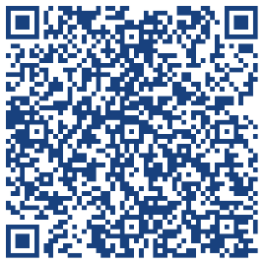Do **NOT** boil water to attempt to remove lead.
* For pregnant persons, infants, and young children, look for alternative sources or treatment of water such as bottled water or use water filters certified for lead removal.
* Identify and replace home plumbing fixtures containing lead.
* Clean faucet screen (also known as aerator) on a regular basis.
* For general questions on lead exposure, visit NH DHHS Sources of Lead page by scanning the blue QR code.

# Getting My Water Sampled

If you are concerned about lead in your drinking water, you may request to have it tested at no cost to you. Please reach out using the contact information below to request a sample test kit.

# What is a Service Line?

Service lines are the individual pipes that run from the water main in the street into a home or building. Most service lines are owned and maintained by your water provider up to the curb-stop valve, while the portion from the curb-stop to your home is owned by you, the customer. The materials of both the utility side and your side of the service line need to be identified regardless of ownership.

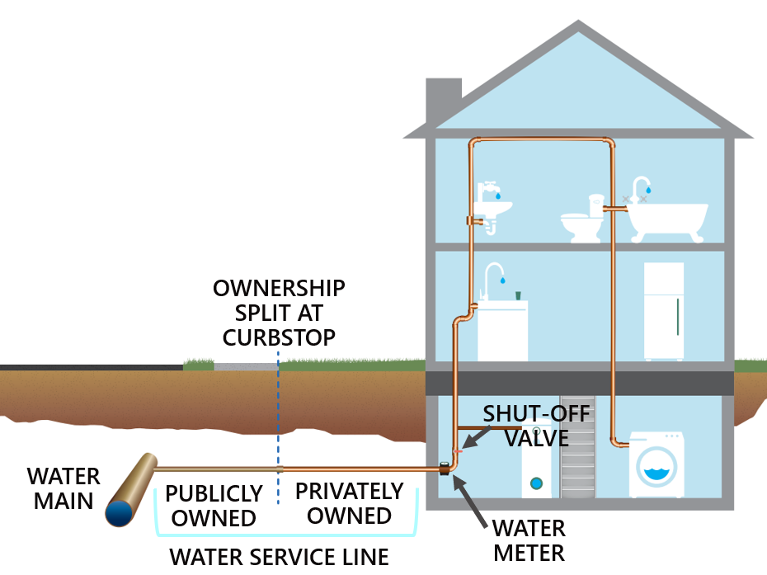

*Figure: Typical scenario of a service line (does not represent all scenarios).*

# Replacement of Your Service Line

All service lines identified as lead or galvanized requiring replacement are required to be replaced on a schedule approved by NHDES. Both the utility side and customer side must be replaced to prevent lead exposure and qualify for funding assistance. Please reach out via the contact information below for more information on service line replacements.

# QR codeAdditional information

Please visit NHDES Lead in Drinking Water (black QR code) for more information about sources of lead and how to reduce your exposure.

For more information on reducing lead exposure from your drinking water and health effects of lead, visit EPA’s website at [www.epa.gov/lead](http://www.epa.gov/lead).

Please contact Hillsborough Water & Sewer Commission if you have questions regarding this letter.

*Penny Griffin, Water & Sewer Administrator*

*63 West Main Street Hillsborough, NH 03244*

*Phone – (603) 464-7982 E-mail – water-sewer@hillsboroughnh.net*